A

Mini Project Report on

LOGO DETECTION AND BRAND RECOGNITION SYSTEM USING AI AND REAL-TIME IMAGE PROCESSING

Submitted for partial fulfilment of the requirements for the award of the degree of

BACHELOR OF TECHNOLOGY IN
COMPUTER SCIENCE AND ENGINEERING (DATA SCIENCE)
By
S. RISHI RUPAK 239P1A6724
M. KARTHIK 239P1A6719
I. SATHWIK REDDY 239P1A6704
M.SHIVARAMAKRISHNA 239P1A6732
Under the Guidance of
Ms.Farhana
Assistant Professor


DEPARTMENT OF COMPUTER SCIENCE AND ENGINEERING

SREE DATTHA GROUP OF INSTITUTIONS
Affiliated to JNTUH, Approved by AICTE Accredited by NBA & NAAC A+, ISO 9001-2008 Certified
Sheriguda (V), Ibrahimpatnam (M), Greater Hyd- 501510
www.sreedattha.ac.in
APRIL - 2026



SREE DATTHA GROUP OF INSTITUTIONS
Affiliated to JNTUH, Approved by AICTE
NBA & NAAC A+ Accredited
Sheriguda (V), Ibrahimpatnam (M), Greater Hyd- 501510
www.sreedattha.ac.in

Certificate

This is to certify that the project entitled “LOGO DETECTION AND BRAND RECOGNITION SYSTEM USING AI AND REAL-TIME IMAGE PROCESSING” is being submitted by S. RISHI RUPAK (239P1A6724), M. KARTHIK (239P1A6719), I. SATHWIK REDDY (239P1A6704), and M. SHIVA RAMA KRISHNA (239P1A6732) in partial fulfillment of the requirements for the award of the degree of Bachelor of Technology in Computer Science and Engineering (DATA SCIENCE). This is a record of bonafide work carried out by them, and the results embodied in this report have been verified and found satisfactory.
.

Signature of Guide Signature of HOD

MS.FARHANA Dr. R. SANTHOSH KUMAR
Assistant Professor Professor and HOD
Department of CSE

Internal Examiner External Examiner

Place: Sheriguda
Date:



SREE DATTHA GROUP OF INSTITUTIONS
Affiliated to JNTUH, Approved by AICTE
NBA & NAAC A+ Accredited
Sheriguda (V), Ibrahimpatnam (M), Greater Hyd- 501510
www.smec.ac.in

DEPARTMENT OF COMPUTER SCIENCE AND ENGINEERING DECLARATION

We, the students of “BACHELOR OF TECHNOLOGY IN COMPUTER SCIENCE AND ENGINEERING (DATA SCIENCE)” session: 2025–2026, Sree Dattha Group of Institutions, Ibrahimpatnam, hereby declare that the work presented in this project entitled “LOGO DETECTION AND BRAND RECOGNITION SYSTEM USING AI AND REAL-TIME IMAGE PROCESSING” is the outcome of our own bonafide work and is correct to the best of our knowledge. This work has been carried out with due consideration of engineering ethics. The results embodied in this project report have not been submitted to any other university or institution for the award of any degree.

S.RISHI RUPAK 239P1A6724
M.KARTHIK 239P1A6719
I.SATHWIK REDDY 239P1A6704
M.SHIVA RAMAKRISHNA 229P1A6732

ACKNOWLEDGEMENT

The satisfaction and euphoria that accompanies the successful completion of any task would be incomplete without the mention of the people who made it possible and whose encouragement and guidance have crowned our efforts with success.
First and foremost, we would like to express our deep sense of gratitude and indebtedness to our College Management for their kind support and permission to use the facilities available in the Institute.
We especially would like to express our deep sense of gratitude and indebtedness of to Dr. P. SANTOSH KUMAR PATRA, Professor and Group Director, Sree Dattha Group of Educational Institutions, Ibrahimpatnam, Greater Hyderabad, for permitting us to undertake this project.
We wish to record our profound gratitude to Dr. M. SENTHIL KUMAR, Principal, Dr. P. RAMA KOTESWARA RAO,Dean,,Sree Dattha Group of Institutions for his motivation and encouragement.
We are also thankful to Dr. R. SANTHOSH KUMAR, Professor and Head of the Department, Department of Computer Science and Engineering, Sree Dattha Group of Educational Institutions, Ibrahimpatnam, for his support and guidance throughout our project as well as Project Coordinator Dr. G. JAWAHERLALNEHRU, Associate Professor , Department of Computer Science and Engineering for his valuable support.
We would like to express our sincere gratitude and indebtedness to our project supervisor to Dr. R. SANTHOSH KUMAR, Professor and HOD, Department of Computer Science and Engineering, Sree Dattha Group of Educational Institutions, Ibrahimpatnam, for his support and guidance throughout our project.
Finally, we express thanks to all those who have helped us successfully completing this project. Furthermore, we would like to thank our family and friends for the immoral support and encouragement. We express thanks to all those who have helped us in successfully completing the project.
S.RISHI RUPAK 239P1A6724
M.KARTHIK 239P1A6719
I.SATHWIK REDDY 239P1A6704
M.SHIVA RAMAKRISHNA 229P1A6732

i

ABSTRACT

Logo detection and brand recognition play a crucial role in brand monitoring, copyright protection, and digital marketing analytics. With the rapid growth of visual content across social media and digital platforms, identifying and tracking brand logos efficiently has become increasingly important. Traditional methods rely on manual inspection or rule-based image processing techniques, which are time-consuming and lack scalability and accuracy. The primary objective of this project is to develop an AI-based system that can detect and recognize logos in real-time with high accuracy and efficiency.
The proposed system utilizes deep learning techniques such as Convolutional Neural Networks (CNNs) and advanced object detection algorithms to identify logos from images and video streams. By leveraging real-time image processing, the system ensures faster response rates and improved performance. The system is designed to store logo data in a structured database, enabling efficient retrieval and comparison for accurate classification. This solution enhances brand visibility analysis, supports intellectual property protection, and provides a scalable approach for real-world applications. The project is implemented using Python and libraries such as OpenCV, along with deep learning frameworks to ensure robust and reliable
.
LIST OF FIGURES
Figure No. | Figure Title | Page No.
3.1.1 | Manual Detection | 5
3.2.1 | Object Detecting By YOLO | 7
3.3.1 | Yolo Architecture | 9
4.2.1 | Use case Diagram | 13
4.3.2 | Class Diagram | 14
4..3.3 | Sequence Diagram | 15
4.3.4 | Activity Diagram | 16
4.3.6 | System Architecture | 18
6.1 | Login and regstriation page | 24
6.2 | After Login User Home Page | 24
6.3 | Logo detecting on a car | 25
6.4 | Logo detecting on a toy car | 25
6.5 | Logo detecting of a company | 26
6.6 | Logo detecting on a truck | 26
6.7 | Logo detecting on a car | 27
6.8 | Logo detecting on a watch | 27
6.9 | Logo detecting on a building | 28

LIST OF ACRONYMS AND DEFINITIONS

S.No. | Acronym | Definition
1. | YOLO | You Only Look Once
2. | R-CNN | Region-based Convolutional Neural Network
3. | CNN | Convolutional Neural Network
4. | OpenCV | Open Source Computer Vision Library
5. | GUI | Graphical User Interface
6. | API | Application Programming Interface
7. | ROI | Region of Interest
8. | AI | Artificial Intelligence

CONTENTS

ACKNOWLEDGEMENT i
ABSTRACT i
LIST OF FIGURES
LIST OF ACRONYMS AND DEFINITIONS CHAPTER 1 INTRODUCTION
  - Objective
  - Overview
iii vi 01
02
03
CHAPTER 2 LITERATURE SURVEY CHAPTER 3 SYSTEM ANALYSIS AND DESIGN
  - Existing System
  - Proposed System
04
05
05

07
  - Algorithm
  - input design
  - output design
09

10

10

CHAPTER 4 SYSTEM REQUIREMENTS & SPECIFICATIONS
  - Hardware Requirements
  - Software Requirements
  - UML Diagrams
    - Use Case Diagram
    - Class Diagram
    - Sequence Diagram
    - Activity Diagram
    - Flowchart Diagram
    - System Architecture
11
11
11
12
13
14
15
16
17
18

4.4 Testing | 19
4.4.1 Unit Testing | 19
4.4.2 Integration Testing | 19
4.4.3 System testing | 19
CHAPTER 5 SOURCE CODE | 20
CHAPTER 6 EXPERIMENTAL RESULTS | 24
CHAPTER 7 CONCLUSION & FUTURE ENHANCEMENT
7.1 CONCLUSION | 28
7.2 FUTURE ENHANCEMENT | 29
REFERENCES | 30

CHAPTER 1

INTRODUCTION
In today’s digital era, the rapid growth of visual content across social media, advertising platforms, and online marketplaces has made brand monitoring and recognition increasingly important. Logos serve as a key element of brand identity, and accurately detecting them is essential for marketing analysis, copyright enforcement, and counterfeit detection. Traditional logo detection methods, such as manual inspection and rule-based image processing, are time-consuming, less efficient, and often fail in complex environments involving variations in lighting, scale, and occlusion.
With advancements in Artificial Intelligence (AI), Machine Learning (ML), and Computer Vision, automated systems can now be developed to improve the accuracy and efficiency of logo detection. Deep learning techniques, particularly Convolutional Neural Networks (CNNs), have shown significant success in image recognition tasks by extracting meaningful features from visual data. Modern object detection algorithms such as YOLO and Faster R-CNN further enhance the capability to detect and classify logos in real-time with high precision.
The Logo Detection and Brand Recognition System using AI and Real-Time Image Processing is designed to automatically identify and classify logos from images and live video streams. The system utilizes OpenCV for image processing and deep learning models for feature extraction and recognition. It captures visual data, processes it, and compares it with a pre-trained database of logos. If a match is found, the corresponding brand is identified; otherwise, the system labels it as unknown.
This system can be applied in various domains such as digital marketing analytics, brand monitoring, intellectual property protection, and real-time surveillance of advertisements. The project demonstrates how AI-driven technologies can be effectively used to build intelligent and scalable logo detection systems, reducing manual effort while improving speed and accuracy.
.

  - OBJECTIVE

The main objective of this project is to develop an intelligent system capable of detecting and recognizing brand logos using artificial intelligence and real-time image processing techniques. The system aims to:

• Detect logos from images and live video streams.
• Extract distinctive features of logos using deep learning algorithms.
• Compare detected logos with a pre-trained brand database.
• Identify and classify the corresponding brand accurately.
• Provide real-time detection and recognition with high efficiency..

  - OVERVIEW

The Logo Detection and Brand Recognition System is an AI-based application that uses machine learning and computer vision techniques to identify and classify brand logos from visual data. The system works by capturing images through a camera or by uploading images manually.
The input image or video frame is processed using OpenCV for preprocessing and logo detection. Once a logo is detected, feature extraction is performed using deep learning models such as Convolutional Neural Networks (CNNs). These extracted features are then converted into numerical representations and compared with a stored database of known logos.
If a match is found, the system displays the identified brand name along with relevant information. If no match is found, the logo is labeled as unknown. The system is capable of operating in real-time, making it suitable for applications such as brand monitoring, digital marketing analysis, and copyright protection.
This project provides an efficient, scalable, and automated solution for logo detection and recognition, contributing to modern intelligent visual analysis systems. The system can handle images with varying backgrounds, lighting conditions, and orientations, ensuring robustness in real-world scenarios. It also supports real-time processing, enabling faster decision-making and analysis.

The system provides:
- High Accuracy: Uses deep learning models to improve detection and classification accuracy.
- Real-Time Processing: Capable of analyzing live video streams efficiently.
- Scalability: Can be expanded by adding more logos to the database.
- User-Friendly Interface: Easy image upload and result visualization through web applications.
- Automation: Reduces manual effort in brand monitoring and analysis.
- Versatility: Can be used in marketing analytics, social media monitoring, and surveillance.
- Performance Optimization: Efficient algorithms ensure faster processing with minimal delay.

The final output of the system provides classification results,accuracy metrics and insights for the brands and how people can identify them
.

CHAPTER 2 LITERATURE SURVEY
The field of logo detection and brand recognition has witnessed significant advancements with the evolution of Artificial Intelligence (AI), Machine Learning (ML), and Computer Vision technologies. Researchers have explored various techniques to improve the accuracy and efficiency of detecting and recognizing logos from images and videos in real-world environments. Early approaches primarily relied on traditional image processing methods and template matching, which were limited in handling variations in scale, orientation, and lighting conditions.
Brown and White (2019) introduced deep learning techniques for OCR-based text recognition, demonstrating how Convolutional Neural Networks (CNNs) can effectively extract features from visual data. Although focused on text, their work laid the foundation for applying CNN-based architectures in image recognition tasks, including logo detection. Similarly, Singh and Patel (2020) explored AI-powered language translation systems, emphasizing the role of AI in processing and interpreting visual and textual information, which indirectly supports advancements in intelligent recognition systems.
Nguyen and Sharma (2021) proposed computer vision techniques for signboard recognition and text processing, highlighting the challenges of extracting meaningful information from real-world images. Their study demonstrated the effectiveness of OCR models in handling multilingual and complex visual data, which is relevant for detecting logos embedded in diverse backgrounds. Later, Martinez and Johnson (2022) introduced transformer-based models for context-aware recognition tasks, showcasing how deep learning can enhance real-time analysis and improve the accuracy of visual recognition systems.
Garcia and Lewis (2023) further extended this work by integrating AI-powered OCR and Natural Language Processing (NLP) for travel assistance applications. Their research emphasized the importance of combining multiple AI techniques to improve accessibility and recognition performance in real-world scenarios. These advancements collectively highlight the transition from traditional rule-based methods to more robust and scalable AI-driven solutions.
The proposed Logo Detection and Brand Recognition System builds upon these developments by integrating deep learning models, real-time image processing, and efficient database management into a unified framework. Unlike earlier methods, this system focuses on accurate logo detection in dynamic environments, ensuring high performance, scalability, and practical applicability in areas such as brand monitoring, digital marketing, and intellectual property protection.

CHAPTER 3

SYSTEM ANALYSIS AND DESIGN

EXISTING SYSTEM

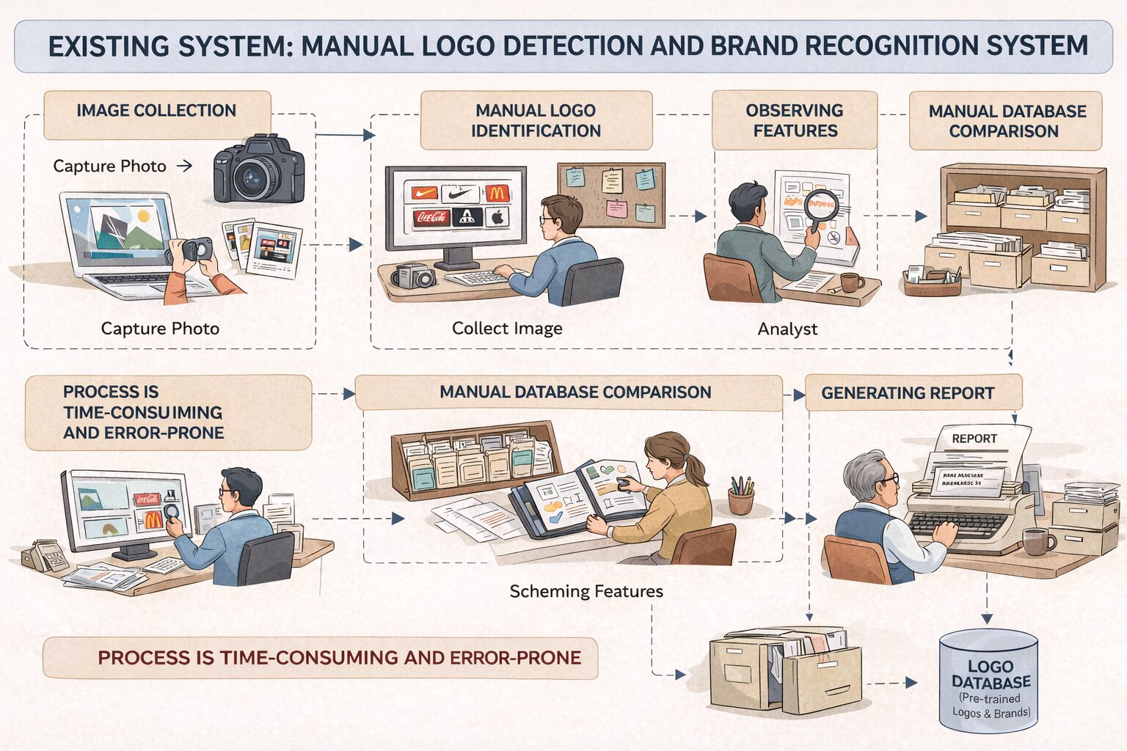
Figure 3.1.1: Manual Detection

Logo detection is a field concerned with identifying and recognizing brand logos from images and video streams. Traditional logo detection systems rely on basic computer vision techniques and manual analysis to detect logos in digital media. These systems often operate under uncontrolled conditions where logos may be affected by occlusion, variations in lighting, changes in orientation, scaling, and background noise. Such challenges make accurate detection difficult and reduce the overall efficiency of the system.
Earlier approaches mainly use template matching and rule-based feature extraction methods. Template matching compares input images with stored logo templates, but it fails when logos are partially visible or transformed. Rule-based methods depend on predefined features such as edges, shapes, or colors, which are not robust enough to handle diverse logo variations. Manual verification is also commonly used, which increases human effort and makes the process time-consuming and inefficient for large-scale applications.
Limitations of Existing System
- Manual Identification: Logo recognition is performed manually, which is time-consuming and requires human effort.
- Low Accuracy: Traditional methods like template matching fail under variations in size, rotation, and lighting conditions.
- Time-Consuming Process: Analyzing large volumes of images manually is inefficient and slow.
- Not Scalable: Existing systems cannot handle large datasets or real-time data effectively.
- Error-Prone: High chances of human error in identifying and classifying logos.
- Poor Performance in Complex Backgrounds: Difficulty in detecting logos in cluttered or noisy environments.
- No Real-Time Processing: Traditional systems are not capable of processing live video streams.
- Limited Adaptability: Hard to update the system with new logos or changes in existing designs.
- Dependency on Human Expertise: Requires skilled analysts for accurate identification.
- Inefficient Feature Extraction: Rule-based methods cannot capture complex visual patterns effectively.

Although combining multiple techniques such as color, shape, and feature-based methods can improve detection performance, it also increases system complexity and computational cost. These hybrid approaches require careful tuning and still may not perform well in dynamic real-world environments. As a result, achieving consistent accuracy and real-time performance remains a significant challenge in traditional .

PROPOSED SYSTEM
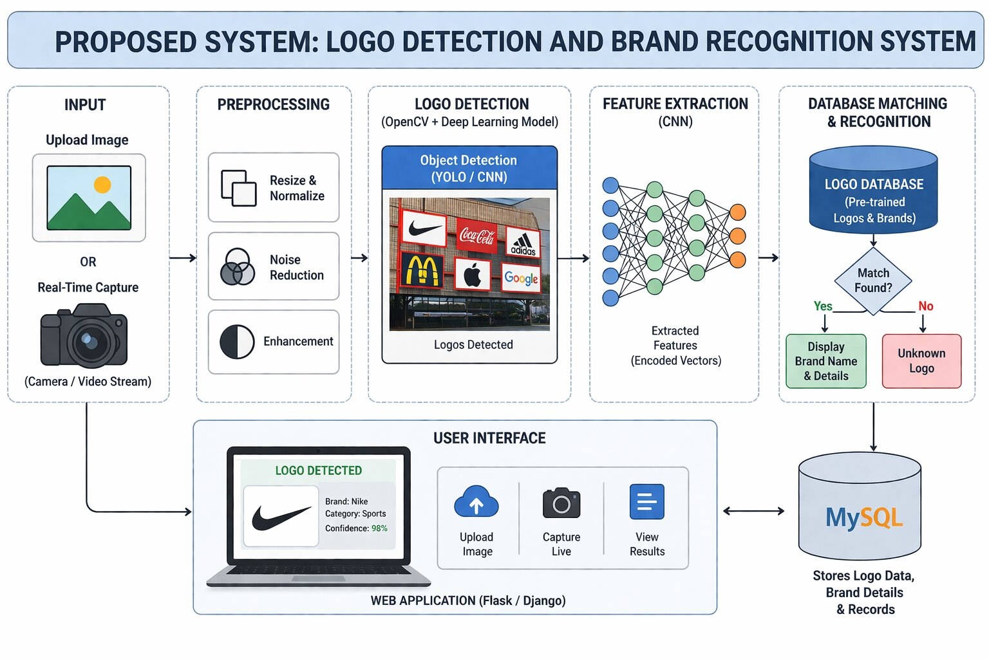
Figure 3.2.1: Object Detection by YOLO

The proposed system is an AI-based Logo Detection and Brand Recognition System that uses deep learning and computer vision techniques to automatically detect and identify brand logos from images and video streams. The system captures images through a camera or accepts uploaded images and processes them using advanced image processing algorithms.
Logo detection is performed using OpenCV and object detection models, which identify logos present in images or video frames. Once a logo is detected, feature extraction is carried out using deep learning models such as Convolutional Neural Networks (CNNs). These features are then converted into numerical representations for further processing.
The system compares the extracted features with a pre-trained database of known logos. If a match is found, the system displays the corresponding brand name and relevant information. If no match is found, the system labels the logo as “Unknown.”
A user-friendly interface is developed using frameworks like Flask or Django, allowing users to upload images, capture real-time input, and view detection results. The system also maintains a database to store logo details and related information for efficient retrieval.

Advantages of Proposed System
- High Accuracy: Uses deep learning models like CNN and YOLO, providing accurate logo detection and classification.
- Real-Time Processing: Capable of detecting and recognizing logos instantly from live video streams.
- Automation: Eliminates manual effort by automatically identifying and classifying logos.
- Scalability: Easily expandable by adding new logos to the database without major changes.
- Robust Performance: Works effectively under different lighting conditions, orientations, and complex backgrounds.
- Fast Processing Speed: Optimized algorithms ensure quick detection and response time.
- Reduced Human Error: Minimizes mistakes compared to manual identification methods.
- User-Friendly Interface: Simple and interactive interface for uploading images and viewing results.
- Efficient Data Management: Stores and retrieves logo information efficiently using databases.
- Versatility: Can be applied in digital marketing, brand monitoring, copyright protection, and social media analysis.
- Cost-Effective: Reduces the need for manual labor and long processing times.
- Improved Decision Making: Provides quick insights for businesses and organizations.

This proposed system provides a fast, accurate, and automated solution for logo detection and brand recognition, making it suitable for applications such as digital marketing, brand monitoring, and real-time visual analysis.

ALGORITHM.

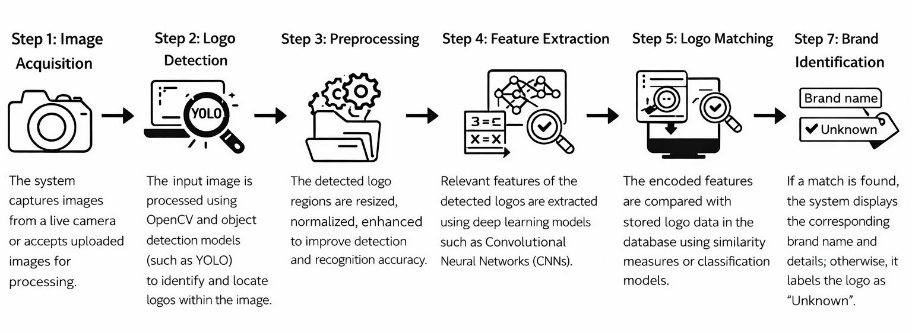

Figure 3.3.1: Detailed Design

The system follows a step-by-step process for criminal identification using face recognition:
Step1: Image Acquisition
The system captures images from a live camera or accepts uploaded images for processing.
Step 2: Logo Detection
The input image is processed using OpenCV and object detection models (such as YOLO) to identify and locate logos within the image.
Step 3: Preprocessing
The detected logo regions are resized, normalized, and enhanced to improve detection and recognition accuracy.
Step 4: Feature Extraction
Relevant features of the detected logos are extracted using deep learning models such as Convolutional Neural Networks (CNNs).
Step 5: Feature Encoding
The extracted features are converted into numerical representations (feature vectors) for efficient comparison.
Step 6: Logo Matching
The encoded features are compared with stored logo data in the database using similarity measures or classification models.
Step 7: Brand Identification
If a match is found, the system displays the corresponding brand name and details; otherwise, it labels the logo as “Unknown”.

INPUT DESIGN

Input Design defines how data is collected, processed, and validated before being used by the system. In the Logo Detection and Brand Recognition System, the primary input is image or video data containing logos, obtained either from a live camera feed or uploaded images. The system accepts input in the form of images or real-time video streams for processing. These inputs are analyzed using OpenCV and deep learning models to detect logos within the visual data.
The captured images are validated to ensure proper format, clarity, and resolution. Preprocessing steps such as resizing, normalization, and noise reduction are applied to improve detection accuracy and performance. The system also supports manual input, where users can upload images through a user interface. Proper validation mechanisms are implemented to handle invalid or corrupted files, ensuring system reliability. If no logo is detected, the system displays an appropriate message to the user.
Multiple input sources, such as webcams, CCTV cameras, or stored image datasets, can be efficiently managed by the system. The design ensures smooth data flow with minimal delay, making it suitable for real-time applications. Overall, the input design ensures that accurate and valid data is provided to the system for effective logo detection and brand recognition.

OUTPUT DESIGN

Output Design defines how the system presents the results after processing the input data. In the Logo Detection and Brand Recognition System, the output includes detection results, classification details, and visual representations of identified logos. The system displays the detected logo with a bounding box along with the corresponding brand name when a match is found. If no match is identified, the system labels the logo as “Unknown.”
The results are presented through a graphical interface, which may include images or live video feed with highlighted detections. The system can also store recognition results in a database for future reference and analysis. In real-time applications, the system can provide instant outputs, enabling quick decision-making for brand monitoring and analysis. Logs containing information such as date, time, and detection status may also be generated.
Additionally, the system can generate reports and insights to support marketing analytics and intellectual property monitoring. Error messages are displayed in case of invalid inputs or system issues, ensuring smooth user interaction. The output design ensures that the results are clear, accurate, and useful for applications such as digital marketing, brand tracking, and automated visual analysis.

CHAPTER 4

SYSTEM REQUIREMENTS & SPECIFICATIONS

  - HARDWARE REQUIREMENTS
- Processor: Intel Core I5 Or Higher (I7 Recommended For Better Performance)
- RAM: Minimum 8 GB (16 GB Recommended For Smooth Real-Time Processing)
- Storage: Minimum 256 GB SSD (SSD Preferred For Faster Data Access)
- Camera: Webcam Or CCTV/IP Camera For Capturing Images And Video Streams
- GPU (Optional): NVIDIA GPU (E.G., GTX 1650 Or Higher) For Faster Deep Learning Model Execution
- Network: Stable Internet Connection (Required For Updates, Datasets, Or Cloud Integration If Used)
- Power Backup: UPS Or Battery Backup For Uninterrupted System Operation

SOFTWARE REQUIREMENTS:

Operating System: Windows 10/11 or Linux

Programming Language: Python 3.12.9 or above

Libraries/Frameworks:
o OpenCV
o TensorFlow / PyTorch (for deep learning models)
o NumPy
o Matplotlib (for visualization, optional)
o scikit-learn (for additional ML utilities, optional)

Web Framework (if required): Flask or Django

Development Tools: Jupyter Notebook / VS Code / PyCharm

Browser: Google Chrome / Mozilla Firefox

UML DIAGRAMS
UML stands for Unified Modeling Language. UML is a standardized general-purpose modeling language in the field of object-oriented software engineering. The standard is managed, and was created by, the Object Management Group.
The goal is for UML to become a common language for creating models of object oriented computer software. In its current form UML is comprised of two major components: a Meta-model and a notation. In the future, some form of method or process may also be added to; or associated with, UML.
The Unified Modeling Language is a standard language for specifying, Visualization, Constructing and documenting the artifacts of software system, as well as for business modeling and other non-software systems.
The UML represents a collection of best engineering practices that have proven successful in the modeling of large and complex systems.
The UML is a very important part of developing objects oriented software and the software development process. The UML uses mostly graphical notations to express the design of software projects.

GOALS:
The Primary goals in the design of the UML are as follows:
- Provide users a ready-to-use, expressive visual modeling Language so that they can develop and exchange meaningful models.
- Provide extendibility and specialization mechanisms to extend the core concepts.
- Be independent of particular programming languages and development process.
- Provide a formal basis for understanding the modeling language.
- Encourage the growth of OO tools market.
- Support higher level development concepts such as collaborations, frameworks, patterns and components.
- Integrate best practices.

  - USECASE DIAGRAM

A Use Case Diagram represents the interaction between users (actors) and the system. It shows the various functionalities provided by the Criminal Identification System.
In this system, the main actors are the User and the Admin. The User interacts with the system to upload images or capture real-time images, while the Admin manages the database and monitors the system.
The main use cases include uploading images, detecting faces, recognizing faces, viewing results, and storing data. The diagram illustrates how users interact with the system and how different functionalities are connected.
This diagram helps in understanding the system requirements and user interactions in a simple and clear manner..

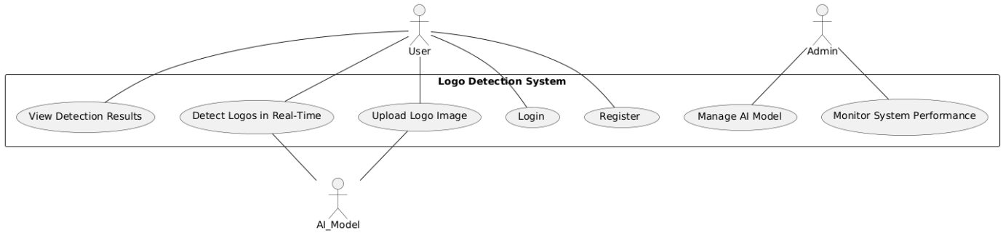

Figure 4.3.1: Usecase Diagram

    - Class Diagram:

The Class Diagram represents the structural design of the system by showing different classes, their attributes, methods, and relationships. In the Criminal Identification System, the main classes include User, ImageProcessor, FaceRecognizer, and Database. Each class is responsible for specific operations. For example, the ImageProcessor class handles face detection and preprocessing, while the FaceRecognizer class performs feature extraction and matching. The Database class is used to store and retrieve facial data and identification results. The relationships between these classes ensure smooth data flow and system functionality.
This diagram provides a clear understanding of how different components of the system are organized and interact with each other.

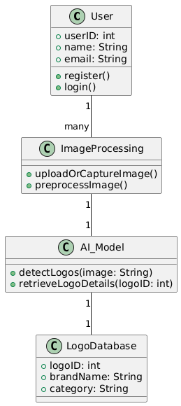

Figure 4.3.2 Class Diagram
    - Sequence Diagram:
The Sequence Diagram illustrates the interaction between different components of the system in a sequential order. In this system, the process begins when the user uploads an image or captures it through a camera. The system then processes the input and detects logos using OpenCV and image processing techniques. The detected logo is passed to the deep learning model for feature extraction.
The extracted features are then compared with the stored logo database to identify a match. Based on the comparison results, the system displays the corresponding brand name if a match is found, or labels it as “Unknown” if no match exists. This diagram helps in understanding the step-by-step flow of operations and how different components interact and communicate during the execution of the system.
In addition, the sequence diagram highlights the role of each system component such as the user interface, processing module, detection module, feature extraction module, and database. It clearly shows how requests are initiated by the user and how responses are generated by the system after processing. The interaction between modules ensures smooth data flow and efficient execution of tasks.
The diagram also represents the time-ordered sequence of operations, making it easier to identify delays, dependencies, and communication between different modules. This helps developers in optimizing system performance and improving overall efficiency. Furthermore, it provides a clear understanding of how real-time processing is achieved by continuously capturing frames and analyzing them sequentially.
Overall, the sequence diagram serves as an important tool for visualizing system behavior, validating the design, and ensuring proper coordination between all components involved in the logo detection and brand recognition process.
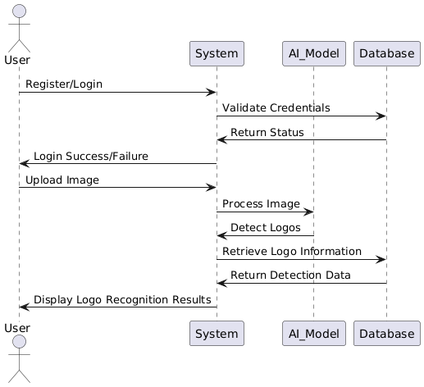
Figure 4.3.3: Sequence Diagram

    - ACTIVITY DIAGRAM:

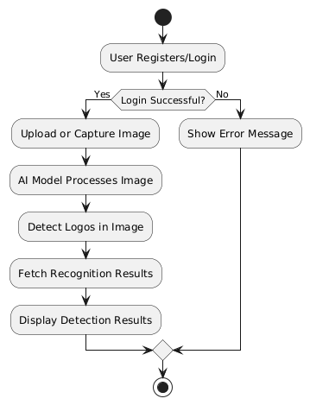

Figure 4.3.4: Activity Diagram

Activity diagrams are graphical representations of workflows of stepwise activities and actions[1] with support for choice, iteration and concurrency. In the Unified Modeling Language, activity diagrams are intended to model both computational and organizational processes (i.e., workflows), as well as the data flows intersecting with the related activities.[2][3] Although activity diagrams primarily show the overall flow of control, they can also include elements showing the flow of data between activities through one or more data stores.[citation needed]Activity diagrams are graphical representations of workflows of stepwise activities and actions[1] with support for choice, iteration and concurrency. In the Unified Modeling Language, activity diagrams are intended to model both computational and organizational processes (i.e., workflows), as well as the data flows intersecting with the related activities.[2][3] Although activity diagrams primarily show the overall flow of control, they can also include elements showing the flow of data between activities through one or more data stores.[citation needed]
The Activity Diagram represents the workflow of the system from start to end. It shows the sequence of activities involved in the criminal identification process.
The process starts with capturing or uploading an image, followed by face detection. The system then extracts facial features and compares them with the database.
A decision is made to check whether a match is found or not. If a match is found, the system displays the person’s details; otherwise, it shows the person as unknown.
This diagram helps in understanding the overall process flow and decision-making steps within the system.

    - FLOWCHAT DIAGRAM:
A flowchart is a diagram depicting a process, a system or a computer algorithm. It is a diagrammatic representation of the solution to a given problem but, more importantly, it provides a breakdown of the essential steps to solving the problem. When designing and planning a process, flowcharts can help you identify its essential steps and simultaneously offer the bigger picture of the process. It organises the tasks in chronological order and identify them by type, e.g. process, decision, data, etc. Each step is independent of implementation as the flowchart only describes what should happen at that step, what input is needed and what the output of the step is but it says nothing about how to implement the step.
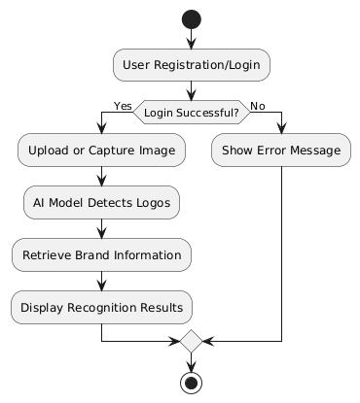
Figure 4.3.5: Flowchart Diagram

: SYSTEM ARCHITECTURE

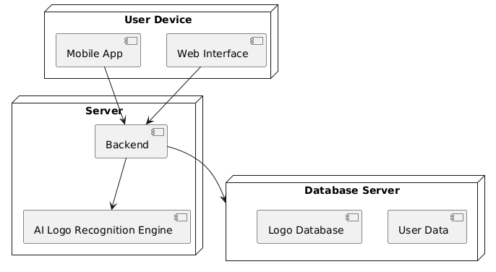

Figure 4.3.5: System Architecture

The System Architecture represents the overall structure and working of the Logo Detection and Brand Recognition System. The system begins with image input captured from a camera or uploaded by the user. The input is processed using OpenCV and image processing techniques to detect logos present in the image or video stream. The detected logo regions are then passed to a deep learning model for feature extraction.
The extracted features are compared with the data stored in the logo database to identify and classify the corresponding brand. The results are then displayed through a user interface, allowing users to view the detected logos along with their brand names. The architecture is designed to be modular and scalable, ensuring efficient performance and easy integration with real-time applications such as brand monitoring, digital marketing analysis, and visual surveillance systems.

TESTINGS

: Unit testing

Unit testing involves testing individual components or modules of the system separately to ensure that each part works correctly. In the Logo Detection and Brand Recognition System, unit testing is performed on different modules such as image input, logo detection, feature extraction, and database operations. For example, the logo detection module is tested using sample images to verify whether logos are detected accurately under different conditions.
Similarly, the feature extraction module is tested to ensure that it correctly extracts meaningful features from detected logos. Database operations such as storing and retrieving logo information are also tested independently. Unit testing helps in identifying errors at an early stage and ensures that each module performs as expected before integration.

: Integration testing

Integration testing is used to verify that different modules of the system work together correctly. In this system, integration testing is performed by combining modules such as image input, logo detection, feature extraction, and database matching. The system is tested to ensure smooth data flow between these components.
For example, after capturing or uploading an image, the system should correctly pass it to the logo detection module, then to the feature extraction module, and finally to the database for comparison and classification. This testing helps identify issues such as data mismatches, communication errors, or delays between modules. It ensures that the entire system functions properly as a complete unit
.

4.3.3 : System Testing

System testing involves testing the complete system as a whole to verify that it meets the specified requirements. The Logo Detection and Brand Recognition System is tested using various images and real-time video streams to ensure accurate logo detection and classification.
The system is evaluated based on performance, speed, accuracy, and reliability under different conditions such as varying lighting, backgrounds, and image quality. This testing ensures that all components work together efficiently and the system performs effectively in real-world scenarios.

CHAPTER 5

CODE

import customtkinter as ctk
import tkinter as tk
from tkinter import filedialog, messagebox
import sqlite3
from PIL import Image, ImageTk
import cv2
import numpy as np
from roboflow import Roboflow
import supervision as sv
import os

# Set appearance
ctk.set_appearance_mode("dark")
ctk.set_default_color_theme("blue")

# App setup
app = ctk.CTk()
app.geometry("800x600")
app.title("Logo Detection")
app.configure(fg_color="#222222")

# SQLite setup
conn = sqlite3.connect("users.db")
cursor = conn.cursor()
cursor.execute('''
CREATE TABLE IF NOT EXISTS users (
username TEXT, password TEXT, phone TEXT, email TEXT,
gender TEXT, address TEXT
)
''')
conn.commit()

# Global user
current_user = None

# Function: Clear screen widgets
def clear_widgets():
for widget in app.winfo_children():
widget.destroy()

# Function: Register page
def register_page():
clear_widgets()
ctk.CTkLabel(app, text="User Registration", font=("Arial", 24)).pack(pady=20)

global reg_username, reg_password, reg_phone, reg_email, reg_gender, reg_address
reg_username = ctk.CTkEntry(app, placeholder_text="Username")
reg_username.pack(pady=5)
reg_password = ctk.CTkEntry(app, placeholder_text="Password", show="*")
reg_password.pack(pady=5)
reg_phone = ctk.CTkEntry(app, placeholder_text="Phone")
reg_phone.pack(pady=5)
reg_email = ctk.CTkEntry(app, placeholder_text="Email")
reg_email.pack(pady=5)
reg_gender = ctk.CTkOptionMenu(app, values=["Male", "Female", "Other"])
reg_gender.pack(pady=5)
reg_address = ctk.CTkTextbox(app, height=70, width=300)
reg_address.pack(pady=5)

ctk.CTkButton(app, text="Register", command=register_user).pack(pady=10)
ctk.CTkButton(app, text="Back to Login", command=login_page).pack()

# Function: Login page
def login_page():
clear_widgets()
ctk.CTkLabel(app, text="Login", font=("Arial", 24)).pack(pady=20)

global log_username, log_password
log_username = ctk.CTkEntry(app, placeholder_text="Username")
log_username.pack(pady=5)
log_password = ctk.CTkEntry(app, placeholder_text="Password", show="*")
log_password.pack(pady=5)

ctk.CTkButton(app, text="Login", command=login_user).pack(pady=10)
ctk.CTkButton(app, text="Register", command=register_page).pack()

# Function: Register user
def register_user():
username = reg_username.get()
password = reg_password.get()
phone = reg_phone.get()
email = reg_email.get()
gender = reg_gender.get()
address = reg_address.get("1.0", "end-1c")

if not all([username, password, phone, email, gender, address]):
messagebox.showerror("Error", "Please fill all fields")
return

cursor.execute("INSERT INTO users VALUES (?, ?, ?, ?, ?, ?)", (username, password, phone, email, gender, address))
conn.commit()
messagebox.showinfo("Success", "Registration successful!")
login_page()

# Function: Login user
def login_user():
global current_user
username = log_username.get()
password = log_password.get()
cursor.execute("SELECT * FROM users WHERE username=? AND password=?", (username, password))
if cursor.fetchone():
current_user = username
homepage()
else:
messagebox.showerror("Login Failed", "Invalid credentials")

# Function: Homepage
def homepage():
clear_widgets()
ctk.CTkLabel(app, text=f"Welcome {current_user}", font=("Arial", 22)).pack(pady=20)
ctk.CTkButton(app, text="Upload Image to Detect Logo", command=browse_image).pack(pady=10)
ctk.CTkButton(app, text="Logout", command=login_page).pack(pady=10)

# Function: Browse and detect
def browse_image():
file_path = filedialog.askopenfilename(filetypes=[("Image files", "*.jpg *.jpeg *.png")])
if file_path:
detect_logo(file_path)

# Function: Detect logo using Roboflow
def detect_logo(image_path):
try:
rf = Roboflow(api_key="GBXneGBgt2OeLyBC5BSJ")
project = rf.workspace().project("logo-detector-cgxef")
model = project.version(2).model

image = cv2.imread(image_path)
result = model.predict(image_path, confidence=40, overlap=30).json()

boxes, confidences, class_names = [], [], []

for pred in result["predictions"]:
x, y, w, h = pred["x"], pred["y"], pred["width"], pred["height"]
x1, y1, x2, y2 = x - w / 2, y - h / 2, x + w / 2, y + h / 2
boxes.append([x1, y1, x2, y2])
confidences.append(pred["confidence"])
class_names.append(pred["class"])

unique_classes = list(set(class_names))
class_name_to_id = {name: idx for idx, name in enumerate(unique_classes)}
class_ids = [class_name_to_id[name] for name in class_names]

detections = sv.Detections(
xyxy=np.array(boxes),
confidence=np.array(confidences),
class_id=np.array(class_ids)
)

label_annotator = sv.LabelAnnotator()
box_annotator = sv.BoxAnnotator()

annotated_image = box_annotator.annotate(scene=image, detections=detections)
annotated_image = label_annotator.annotate(scene=annotated_image, detections=detections, labels=class_names)

sv.plot_image(image=annotated_image, size=(12, 12))
except Exception as e:
messagebox.showerror("Error", f"Failed to detect logo: {e}")

# Start app with login page
login_page()
app.mainloop()

CHAPTER 6

EXPERIMENTALS AND RESULTS

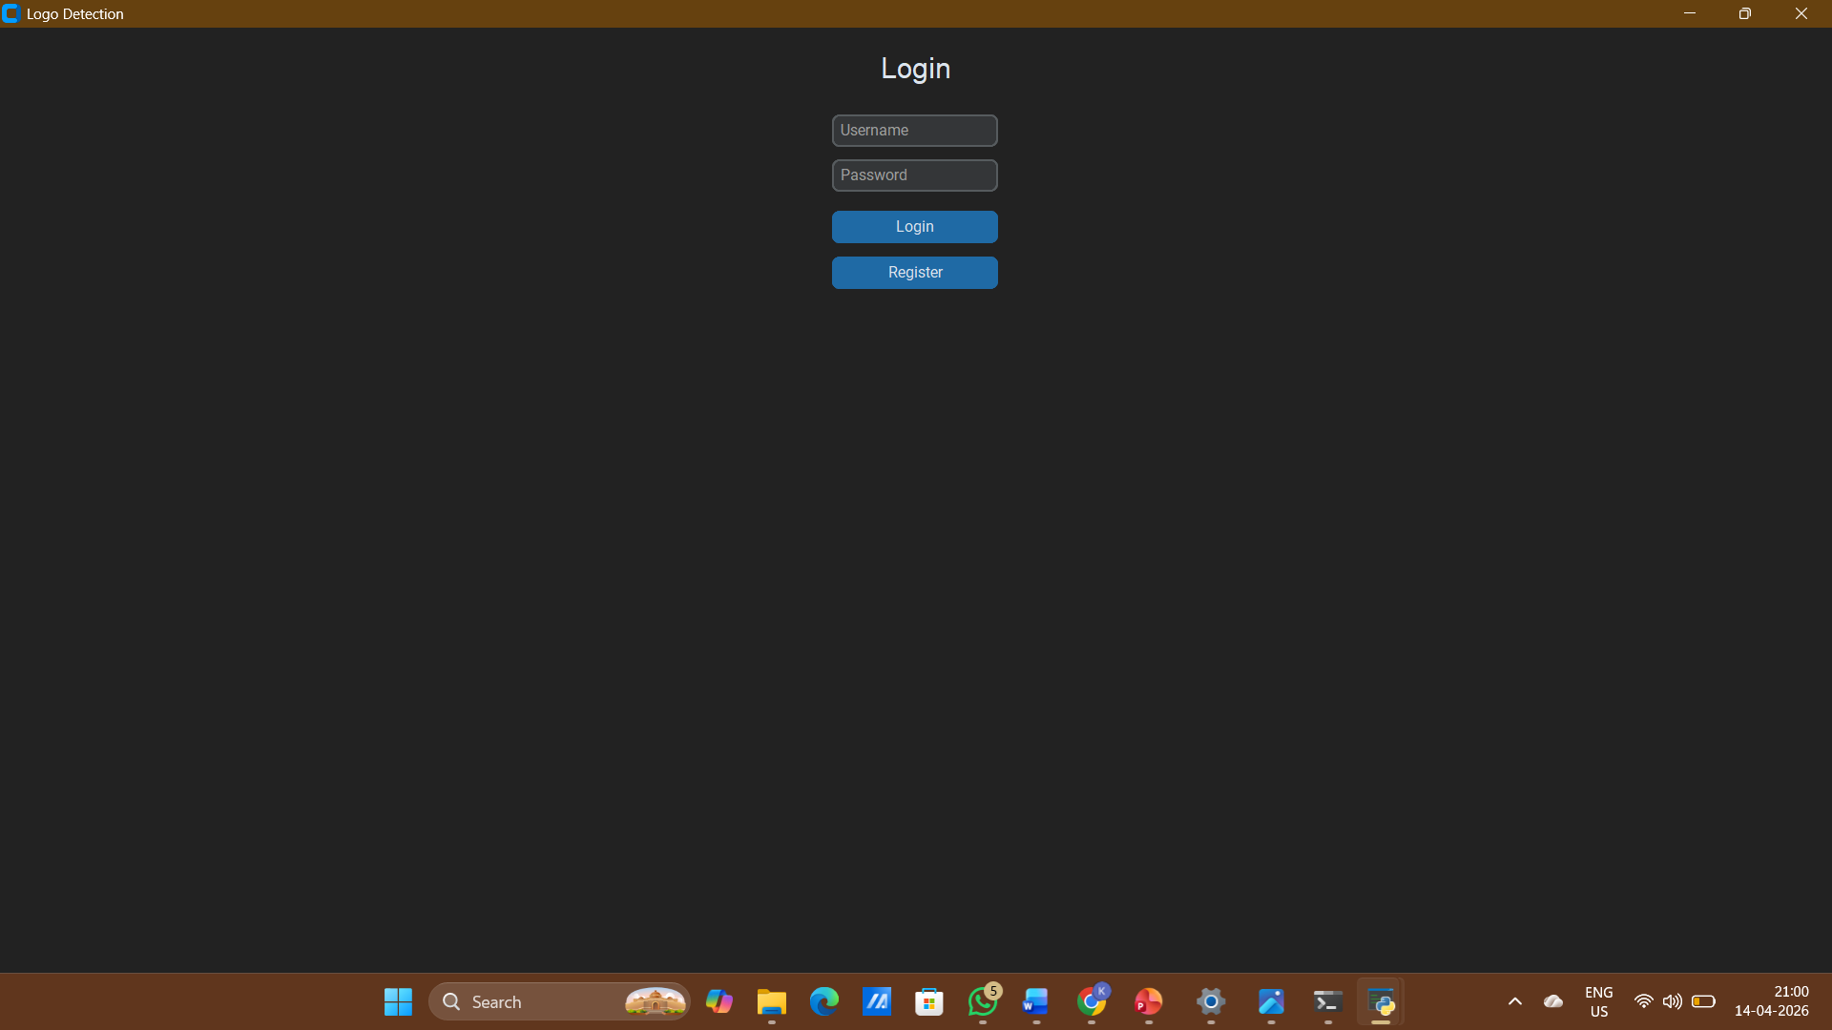

Figure 6.1:Login Page And Regstriation Page

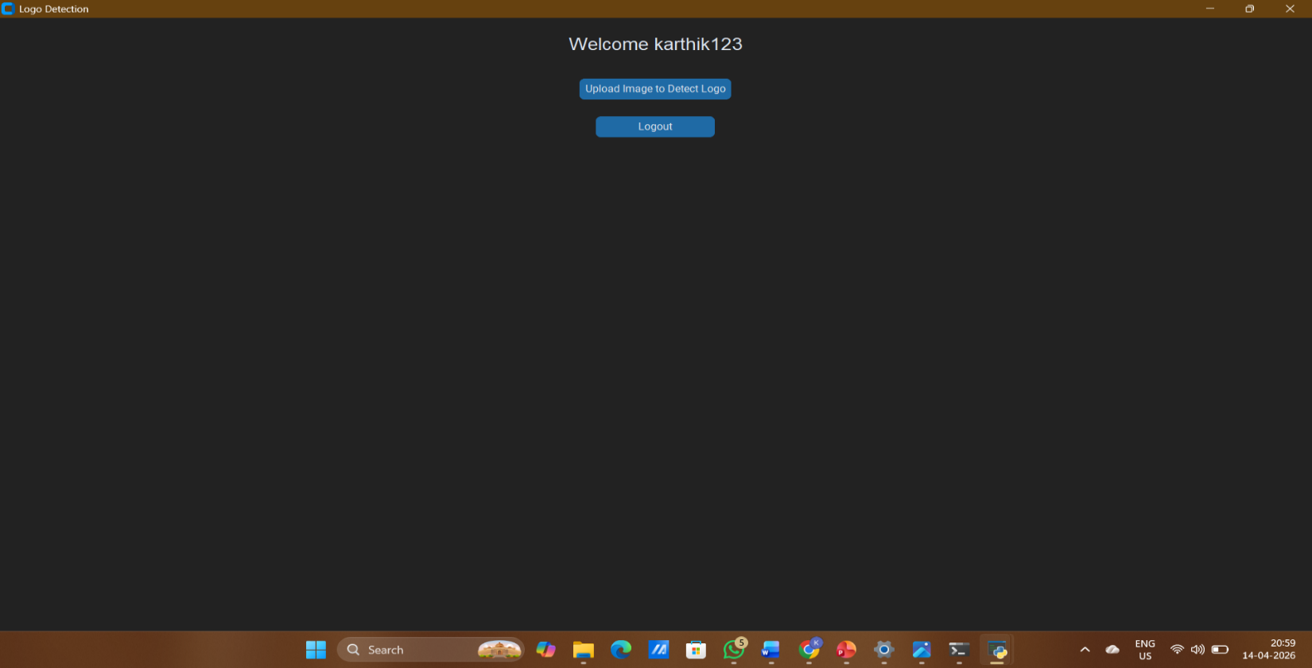

Figure 6.2:Homepage
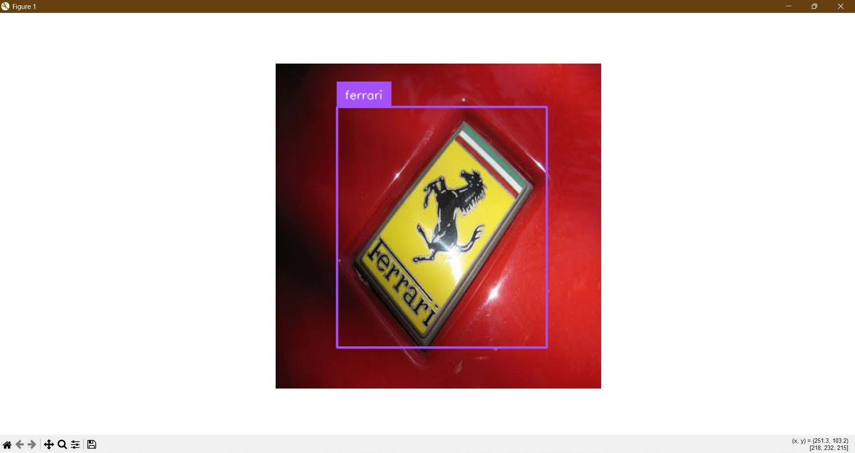

Figure 6.3: Logo Detecting On A Car

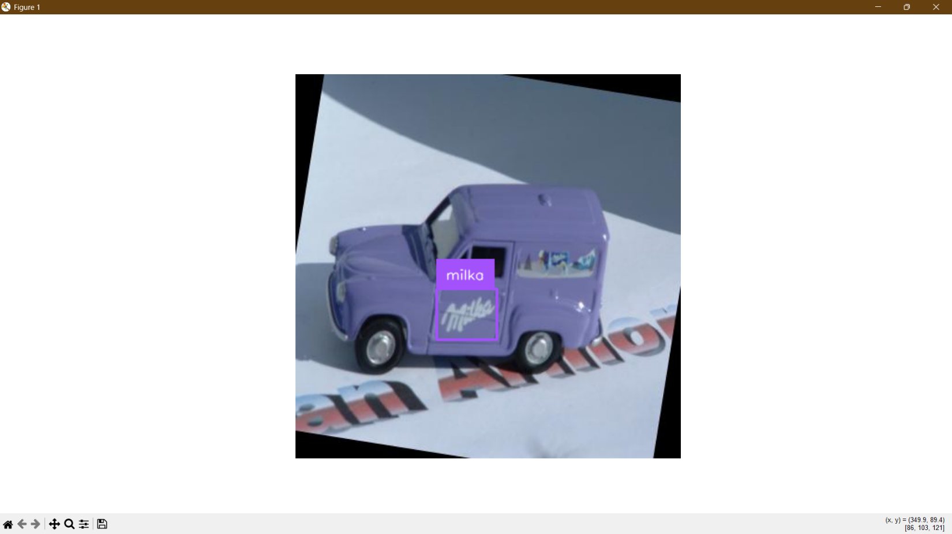

Figure 6.4: Logo Detecting On A Toy Car

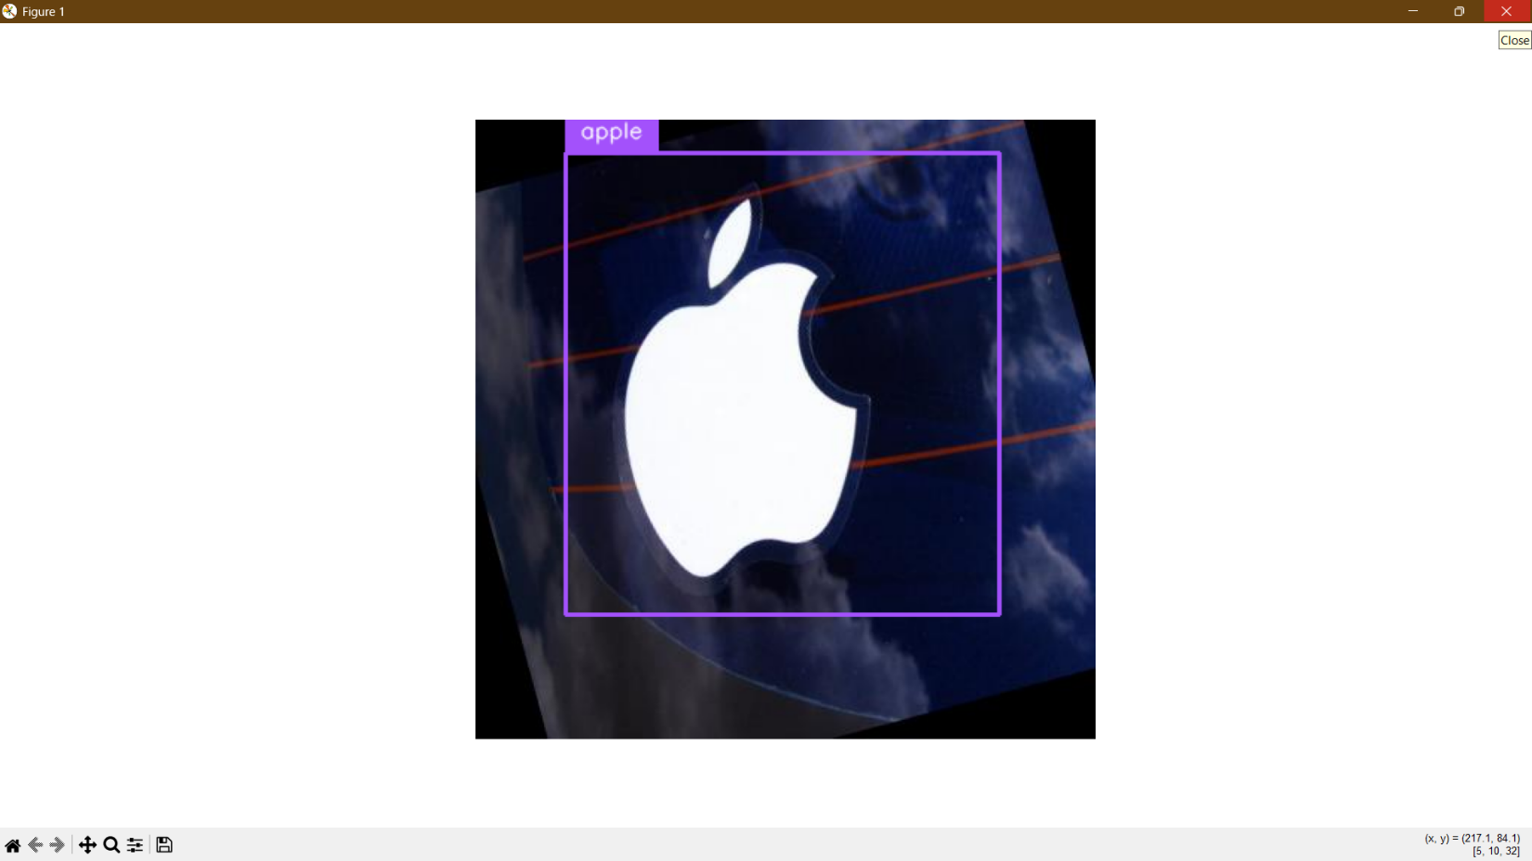

Figure 6.5: Logo Detection Of A Company

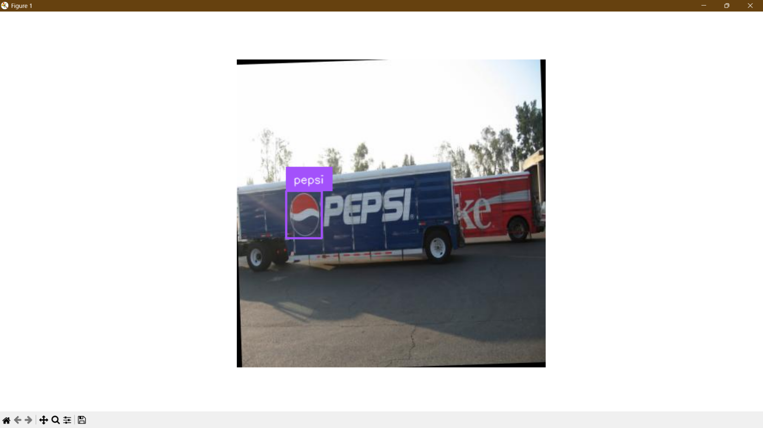

Figure 6.6: Detecting A Logo On A Truck

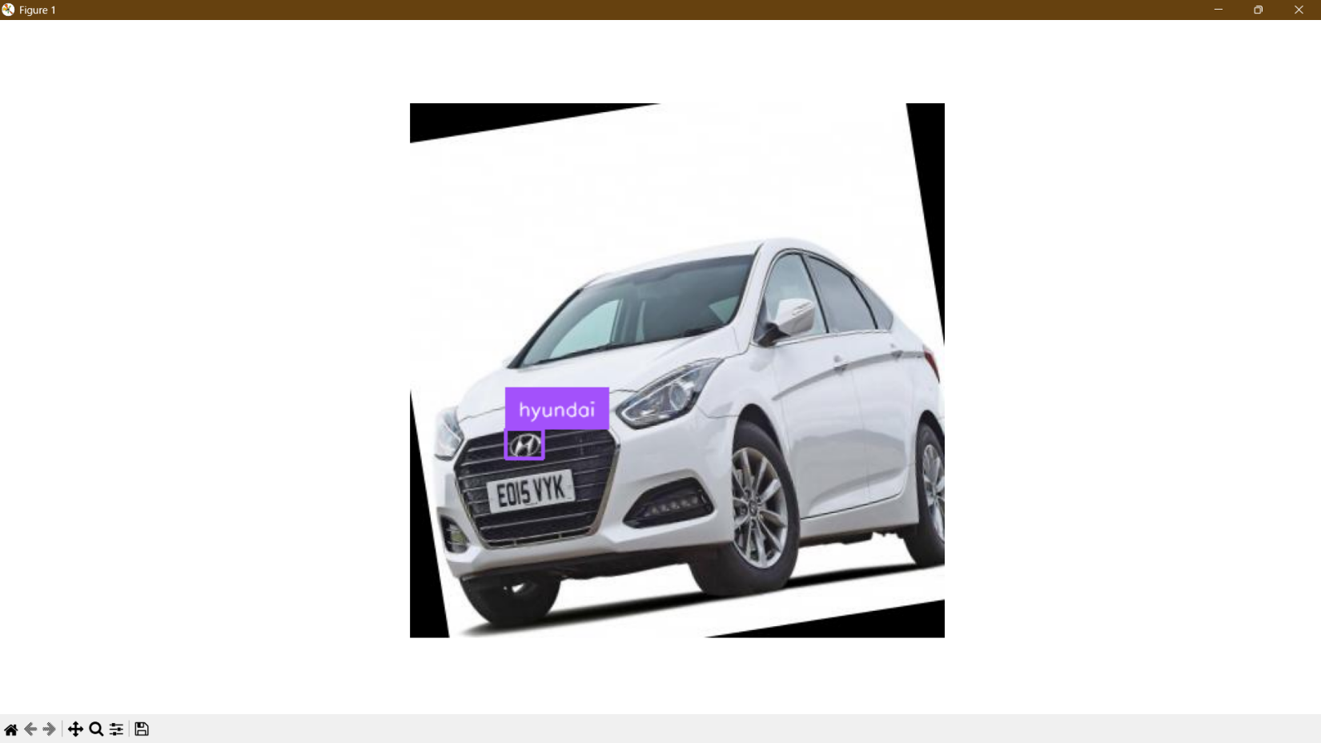

Figure 6.7: Detecting A Logo On A Car

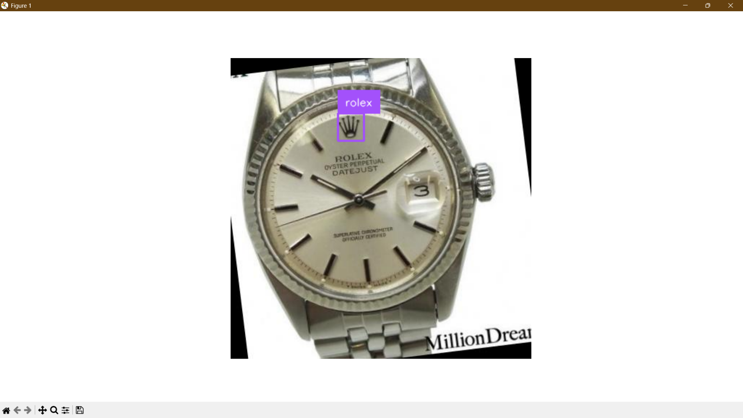

Figure 6.8: Detecting Logo On A Watch

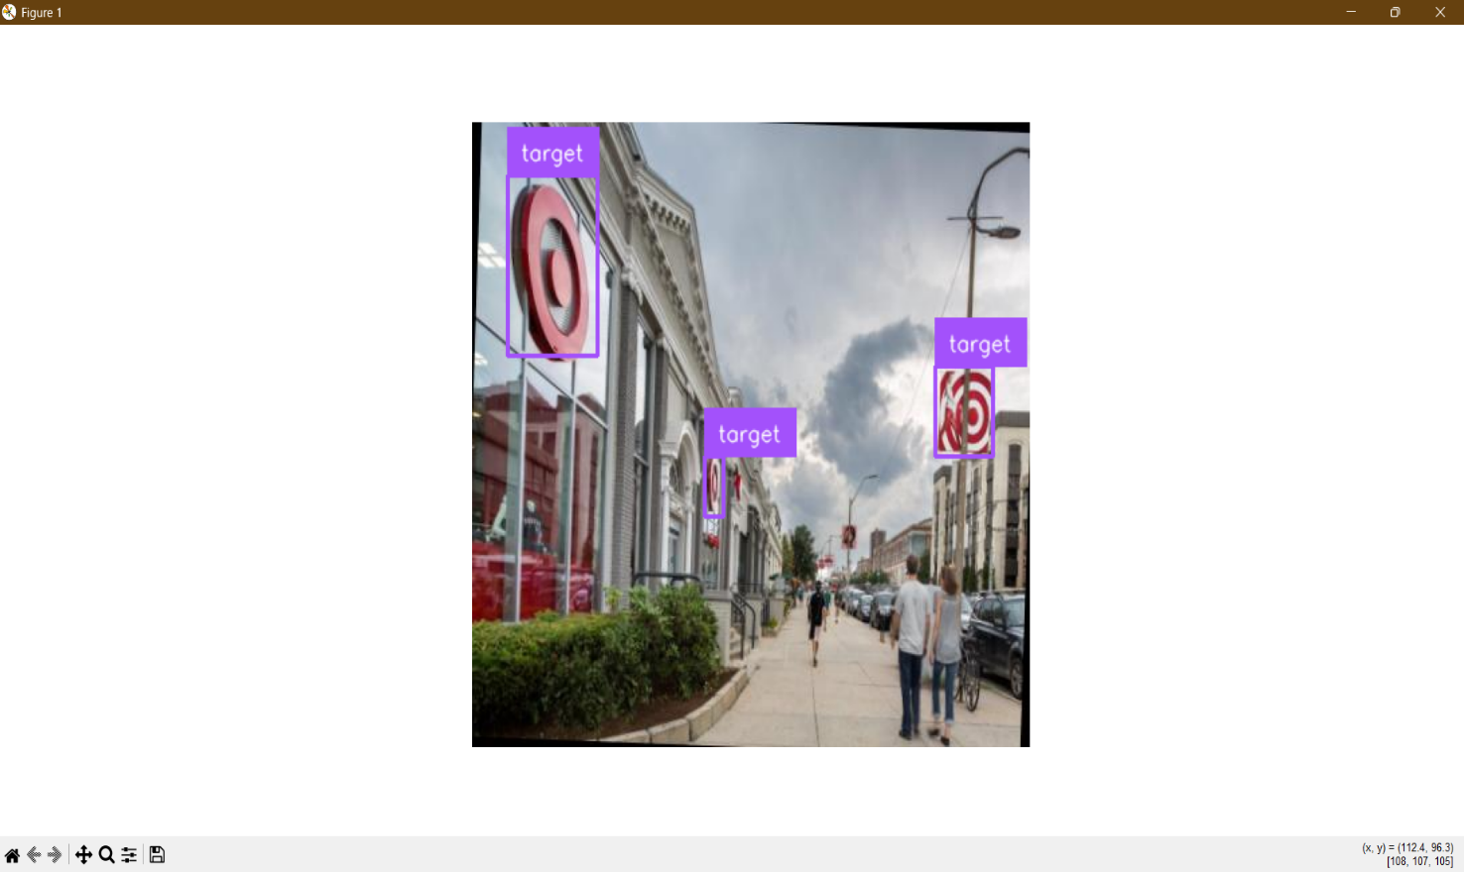

Figure 6.9: Detecting Logo On A Building

CHAPTER 7

CONCLUSION & FUTURE ENHANCEMENT

  - CONCLUSION

The Logo Detection and Brand Recognition System using Artificial Intelligence and Real-Time Image Processing successfully demonstrates the application of AI and Computer Vision in the field of digital analytics and brand monitoring. The system is capable of detecting and recognizing logos from images and real-time video streams with good accuracy and efficiency.
By integrating technologies such as OpenCV, deep learning models, and database systems, the project provides an automated solution for identifying and classifying brand logos. The system reduces manual effort, minimizes errors, and improves the speed of detection compared to traditional methods.
The implementation of this system shows that AI-based logo recognition can be effectively used in real-world applications such as digital marketing, brand monitoring, copyright protection, and advertisement analysis. It enhances efficiency by enabling quick and reliable identification of logos across various platforms.
Furthermore, the system demonstrates scalability and flexibility, allowing it to be extended with advanced models and integrated with real-time applications. It can handle diverse datasets and varying environmental conditions, making it suitable for practical deployment.
Overall, this project highlights the importance of modern AI technologies in developing intelligent, scalable, and efficient systems for logo detection and brand recognition, paving the way for future innovations in automated visual analysis systems.

FUTURE ENHANCEMENT

- Mobile App Integration
Develop a mobile application that allows users to upload images, capture real-time visuals, and receive instant logo detection and brand recognition results on smartphones.
- Real-Time Video Integration
Integrate the system with live video sources such as CCTV or streaming platforms to enable continuous monitoring and real-time logo detection in advertisements, public displays, and media content.
- Advanced Deep Learning Models
Enhance system accuracy by implementing advanced models such as YOLO, Faster R-CNN, or EfficientNet for improved logo detection and classification performance.
- Multi-Logo Detection
Extend the system to detect and recognize multiple logos simultaneously within a single image or video frame, even in complex scenes.
- Cloud Storage Integration
Store logo datasets and detection results on cloud platforms to ensure scalability, secure data management, and easy access from multiple devices.
- Real-Time Alert System
Implement a notification system that alerts users or organizations when specific brand logos are detected in media content or unauthorized usage scenarios.
- Low-Quality Image Enhancement
Improve system performance on low-resolution or blurred images using image enhancement and super-resolution techniques.
- Multi-Language Brand Information
Integrate support for displaying brand details in multiple languages to enhance usability across different regions.

REFERENCES

[1] Krizhevsky, A., Sutskever, I., & Hinton, G. E. (2012). ImageNet Classification with Deep Convolutional Neural Networks. Advances in Neural Information Processing Systems (NIPS).
[2] Redmon, J., Divvala, S., Girshick, R., & Farhadi, A. (2016). You Only Look Once: Unified, Real-Time Object Detection. Proceedings of the IEEE Conference on Computer Vision and Pattern Recognition (CVPR).
[3] Ren, S., He, K., Girshick, R., & Sun, J. (2015). Faster R-CNN: Towards Real-Time Object Detection with Region Proposal Networks. Advances in Neural Information Processing Systems (NIPS).
[4] Simonyan, K., & Zisserman, A. (2014). Very Deep Convolutional Neural Networks for Large-Scale Image Recognition (VGGNet).
[5] He, K., Zhang, X., Ren, S., & Sun, J. (2016). Deep Residual Learning for Image Recognition (ResNet). Proceedings of the IEEE Conference on Computer Vision and Pattern Recognition (CVPR).
[6] Bochkovskiy, A., Wang, C. Y., & Liao, H. Y. M. (2020). YOLOv4: Optimal Speed and Accuracy of Object Detection.
[7] Lin, T. Y., Maire, M., Belongie, S., et al. (2014). Microsoft COCO: Common Objects in Context. European Conference on Computer Vision (ECCV).
[8] Everingham, M., Van Gool, L., Williams, C. K. I., Winn, J., & Zisserman, A. (2010). The Pascal Visual Object Classes (VOC) Challenge. International Journal of Computer Vision.
[9] Girshick, R. (2015). Fast R-CNN. Proceedings of the IEEE International Conference on Computer Vision (ICCV).
[10] Girshick, R., Donahue, J., Darrell, T., & Malik, J. (2014). Rich Feature Hierarchies for Accurate Object Detection and Semantic Segmentation (R-CNN). Proceedings of the IEEE Conference on Computer Vision and Pattern Recognition (CVPR).
[11] Redmon, J., & Farhadi, A. (2018). YOLOv3: An Incremental Improvement.
[12] Tan, M., & Le, Q. (2019). EfficientNet: Rethinking Model Scaling for Convolutional Neural Networks. Proceedings of the International Conference on Machine Learning (ICML).
[13] Szegedy, C., Liu, W., Jia, Y., et al. (2015). Going Deeper with Convolutions (GoogLeNet). Proceedings of the IEEE Conference on Computer Vision and Pattern Recognition (CVPR).
[14] He, K., Gkioxari, G., Dollár, P., & Girshick, R. (2017). Mask R-CNN. Proceedings of the IEEE International Conference on Computer Vision (ICCV).
[15] Liu, W., Anguelov, D., Erhan, D., et al. (2016). SSD: Single Shot MultiBox Detector. European Conference on Computer Vision (ECCV).
[16] Howard, A. G., Zhu, M., Chen, B., et al. (2017). MobileNets: Efficient Convolutional Neural Networks for Mobile Vision Applications.
[17] Sandler, M., Howard, A., Zhu, M., et al. (2018). MobileNetV2: Inverted Residuals and Linear Bottlenecks. Proceedings of the IEEE Conference on Computer Vision and Pattern Recognition (CVPR).
[18] Tan, M., Pang, R., & Le, Q. V. (2020). EfficientDet: Scalable and Efficient Object Detection. Proceedings of the IEEE Conference on Computer Vision and Pattern Recognition (CVPR).

